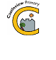
Castleview Primary School
School Closure Work – Primary4
Home Learning Tasks

Updated Core Learning – During school closure periods teachers will post learning grids on their class page of the school website.

Literacy | Numeracy and Maths | Health and Wellbeing
Bug Club  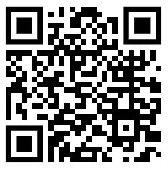  https://www.activelearnprimary.co.uk/login?e=-1&c=0  Continue with your reading at home, try reading a new book in your bug club and complete the quiz.  __________________________  Read your favourite book at home with an adult.  Discuss these questions:  Who are the main characters?  Did you enjoy this book? Why? Why not?  Design a new front cover for the book. | Defenders of mathematica  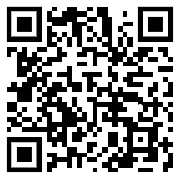  Use the QR code or link to play the games and defend the city of mathematica. Complete a series of maths questions to defeat the challengers.  https://www.bbc.co.uk/games/embed/guardians-mathematica?exitGameUrl=https%3A%2F%2Fbbc.com%2Fbitesize%2Farticles%2Fzn2y7nb  Times Tables Tennis  Select a times table. With another person, alternatively say each station of the table. If you make an error, start the times table again. Try to complete every times table from 2 to 10 with your partner. | This week we have been talking about the parts of our body. Use the link below to identify your similarities and differences.  https://rshp.scot/wp-content/uploads/2024/01/Part-1.-My-body-belongs-to-me-Prop-1.pdf  ______________________  As a family, set yourselves a challenge to improve your health and wellbeing for the next 30 days.  For example:  Quit a bad habit that bothers you.  Spend more time outside.  Complete an act of kindness every day.  Exercise for 30 minutes every day.  Write down what your challenge is and why.


