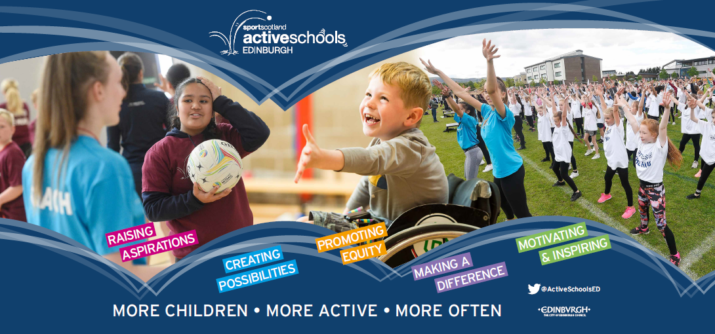


Book online: https://getedinburghactive.spydus.co.uk/

Bookings open – now
Bookings Close – 1/09/2024
Castleview Primary School
Active Schools Extra Curricular Programme
September –October 2024
ASC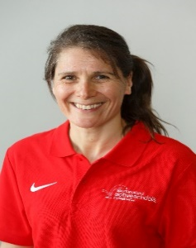 PHOTO
Castlebrae Learning Community
Active Schools Co-ordinator
Shirley Banks
T: 07774468782
E: Shirley.banks@ea.edin.sch.uk

Clubs at Castleview Primary School are for P5-7 pupils until the October break. Clubs will then be offered to P2 pupils.

Spaces are allocated on a first come first served basis and classes have limited spaces. To avoid disappointment please book as soon as possible.

Activity | Age | Day | Time | Dates | Venue | Code
Boys football | P5-P7 | Monday | 3pm-4pm | 2nd 9th 23rd 30th September  7th 28th October  4th 11th 18th 25th November | Castleview astro | CAS - 205
Basketball | P5-P7 | Tuesday | 3pm-4pm | 3rd 10th 17th 24th September  1st 8th October | Castleview gym hall | CAS -206
Dance | P5-P7 | Wednesday | 3pm-4pm | 4th 11th 18th 25th September  2nd 9th October | Castleview dining hall | CAS - 207
Girls football | P4-P7 | Thursday | 3pm-4pm | 5th 12th 19th 26th September  3rd 10th 24th 31st October  7th 14th 21st 28th November | Castleview astro | CAS - 208
Freestyle Gymnastics | P5-P7 | Thursday | 3pm-4pm | 5th 12th 19th 26th September  3rd 10th October. | Castleview astro | CAS - 209

Please note the programme is subject to change – please check the website for the most up to date information.

All extra curricular sessions are off when the schools are off for any holidays:
DATES





How do I book my child’s place?

We have a new booking system launching from this term. Follow the steps below to book online at: https://getedinburghactive.spydus.co.uk/

Step 1: Register.

Follow the link above and click register in the top right hand corner. When registering please use the main contact email address that is on your child’s school record (e.g. SEEMIS/School Database) to register. This will be the easiest and quickest way to book.

Step 2: Book your child’s place.

Insert the booking codes shown in the table above into the search box e.g., SHORTCODE. Your place will be reserved for 15 minutes while you complete your booking, and a confirmation email will be sent on completion.

Step 3: View booked activities.

Visit your dashboard to see the activities your child is booked into and the times

GET ACTIVE WITH ACTIVE SCHOOLS
BOOK INTO AN EXTRA CURRICULAR SESSION



Volunteer with Active Schools

We are recruiting volunteers in a variety of roles to help us provide as many opportunities as possible for children to take part in sport and physical activity! We will provide full training and support. If you want to find out more please contact me.

Call Shirley Banks on 07774468782
or email Shirley.banks@ea.edin.sch.uk

Additional Support Needs

If you feel your child needs additional support to take part in our clubs, please contact us. See below a link to more opportunities and events for children with Additional Support Needs in Edinburgh

Equalities and Inclusion | Edinburgh Active Schools (spydus.co.uk)




@ActiveSchoolsED
@ActiveSchoolsEdinburgh
@ActiveSchoolsEdinburgh


Active Schools Cluster/Community Hub Clubs

Club | Age | Day | Time | Dates | Venue | Delivered by | Online Booking
Girls football | P6-7 | Monday | 3.20pm-4.20pm | 4th 11th 25th September  2nd 9th 30th October  6th 13th 20th November. | Castlebrae Community Campus | Edinburgh South football club | CAS - 19
Please see below the list of Active Schools Primary Cluster sessions and Local Club sessions
that are taking place within the community.




