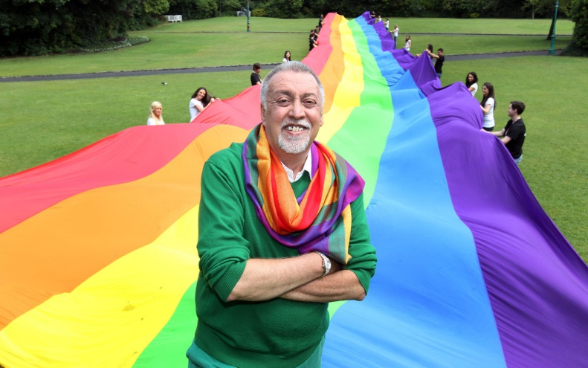

The multi-coloured Rainbow Flag was originally designed by artist and gay rights activist Gilbert Baker in 1978 in San Francisco.

Each colour on the flag stands for something:
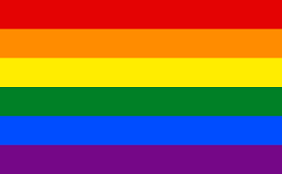
Life
Healing
Sunlight
Nature
Harmony
Spirit

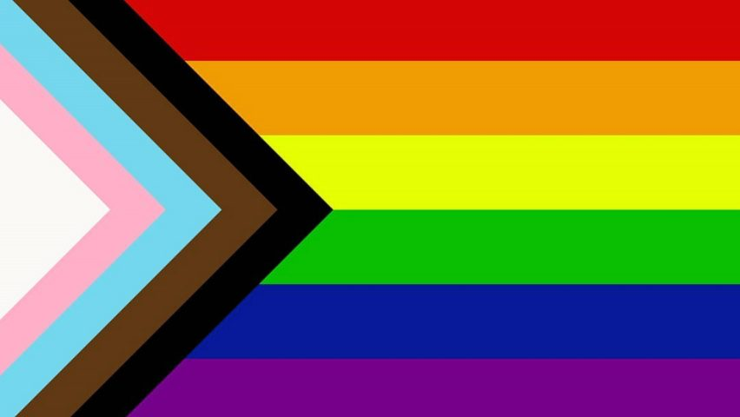
In 2018, graphic designer Daniel Quasar added a five-coloured chevron to the LGBT Rainbow Flag to place a greater emphasis on "inclusion and progression".
The flag includes black and brown stripes to represent marginalised LGBT communities of colour, along with the colours pink, light blue and white, which are used on the Transgender Pride Flag.
The main section of the flag incorporates the six-stripe flag so as to not take away from the initial meaning, while the additional elements form an arrow shape that points to the right, to represent "forward movement". They are placed along the left edge of the flag to state that "progress still needs to be made."

