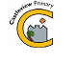
Castleview Primary School
School Closure Work – Mrs Newall
Updated Tasks Week Beginning – 0.2020

Some of our pupils are lucky to be in Literacy and Numeracy Teaching and Learning groups with Mrs Newall, Mrs Jeffrey and Mrs Morrison.
Some pupils are lucky to be taught by Mrs Martin for Health and Wellbeing and Mrs Mack for Outdoor Learning.
During school closure periods when possible these teachers will post a weekly updated version of this document on the school website.
They will update the box(es) below to set tasks for their groups.

Rainbow Group RWI
- Over the week please complete the Handwriting Literacy Sheets – r, m and d
- Can you create and write a sentence including the word walk?

- Can you read the fifth 10 words of Fry’s 100 – see if you spell them too!
- When you are out for your daily walk, can you spot any Fry’s Words? On a poster, the side of a bus?
- You could make your own flashcards and turn them over and read them.
Ongoing Core Learning

Literacy
- Book Bug
- Learning Fry’s words
- Story Writing
Read anything and everything!
Ongoing Activities

Make a structure out of lego / duplo / junk boxes – you choose!  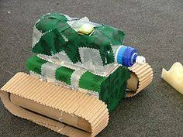 | Ball skills – can you bounce / keep yuppy / throw and catch a ball 10 times? Or more?  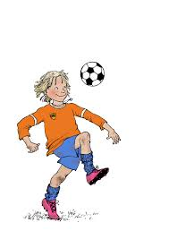 | Share a story from a book or imagination  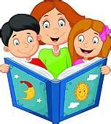
A hunt with someone at home – eg. find a book, something red, a fork etc – you make it up!   | Play a board game, chess or dominoes  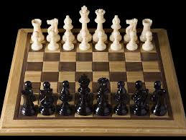 | Take part in Cosmic Yoga  



