Helicopter Stories At Home  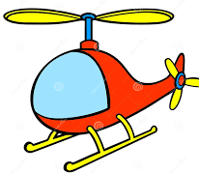  Tell an adult a story to write down. Get them to read it out loud while everyone who wants to acts it out by being one of the characters or objects in the story. | Finger Puppets  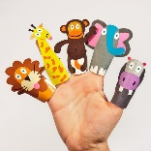  Make some finger puppets of your favourite Fairy Tales. Use paper to make them. Retell the stories using your characters!  Why not make a stage for the puppets? | Small World  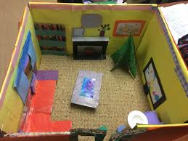  Build your own small world- it could be a house, a shop, a school or castle- from a shoe box or other old box. Use any recycling to build all the details. | Den building  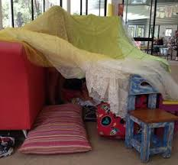  Build yourself a den- inside or outside. Make it cosy and curl up with a book!
Sing-along  Sing some songs and rhymes that you know with your family.  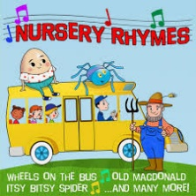  Why not try and make up new words about your favourite animals or your family/friends?!  Can you make it rhyme?! | Dance along  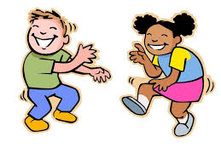  Can you make up some dance moves to a song you know? Could you make actions to fit with the words? | Clapping Games  Do some clapping games with someone at home. Try to hit hands in time with the words.  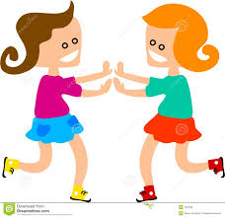 |   Be the teacher  Think about something you learned at school and teach it to someone or a soft toy at home. It could be how to count and read numbers or how to read your sounds!
  Water Play  Put some warmish water in a sink or basin with some bowls, empty plastic bottles and tubs. See how much water fills different bowls and have fun exploring! | Silly string  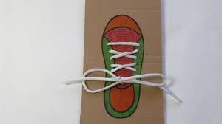  Practise your skills by plaiting 3 pieces of string/ ribbon together. Or tie knots and bows to practise tying your shoes! | 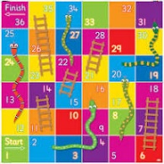  Board Game  Design and make your own game. You could draw pairs to make a matching game or make a snakes and ladders counting up to 20 (or higher!) | 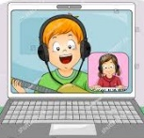  Virtual imagination  Play an imaginary game either with someone at home, an imaginary friend or see if you can call/video chat a friend to play! Maybe you’re astronauts or an explorer reporting back!

