Create a mini sport  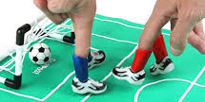  Invent a game that could be played with just your fingers or hands so it is easy to play inside. Give it a name and teach someone at home to play! Have a tournament? | Finger Puppets  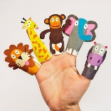  Make some finger puppets of your favourite story. Retell the stories using your characters!  Why not make a stage for the puppets? You could film your show! | Mini Worlds  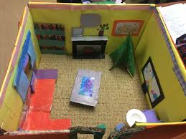  Can you recreate a place (real or imaginary) in miniature? Use a shoe box and add all the details. It could be your house, school, a set from a film… | Den building  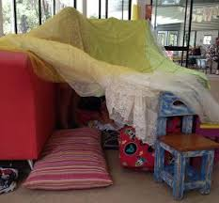  Build yourself a den- inside or outside. Make it cosy and curl up with a book!
  Sing-along  Sing some songs and rhymes that you know.  Why not try and make up new words?  Can you make it rhyme? | Dance along    Can you make up some dance moves to a song you know? Could you make actions to fit with the words? | Clapping Games  Do some clapping games with someone at home. Try to hit hands in time with the words.   |   Be the teacher  Think about something you learned at school and teach it to someone at home or over video chat! How can you make it interesting?
Quiz Time    Make up a quiz to challenge your familiy at home oryou’re your friends virtually. Try to have different rounds with different categories so there is something for everyone! |   Movie Makers  Write a film about anything- could be the adventures of a lego man around your home or your own video diary of your experiences. Plan it, story board it and act it out. If you can, film it. | 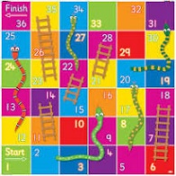  Board Game  Design and make your own game. What is the aim of the game? What makes it unique? Make sure you make all the playing pieces! | Code Crackers  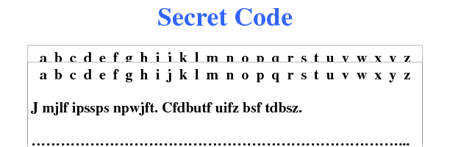  Create a code and send messages to a family member or friend in it! You could tell them how it works or let them try and crack it!

