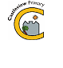

Castleview Primary School
School Closure Work – Primary 5B
Updated Tasks Week Beginning – 23rd March 2020

Updated Core Learning – During school closure periods when possible teachers will post a weekly updated version of this document on the school website. They will change the three boxes below. Tasks may relate to the resource pack sent home or a website.
Please feel free to post any of your completed work on our school twitter page too:
https://twitter.com/Castleview_PS
Please share the work you do with me on twitter- @MissBarker_CV
I look forward to seeing your learning!

Literacy | Numeracy | Health and Wellbeing
- Up level this sentence and continue the story in any way you want – The girl walked into the playground and looked around.  - Read these most commonly used words and use them in a sentence in your jotter –enough, watch, almost, sometimes, mountains, list, song, being, leave, family  - Write a newspaper article detailing the impact Covid 19 has had on schools. (Newsround can help with finding information- https://www.bbc.co.uk/newsround )  - Investigate the book, “The Day We Met the Queen”, in your pack. In your jotter write down – title, author, publisher, date first published, ISBN Number, price  - Website activity- Go to https://spellingframe.co.uk/ Once on this page, select ‘year 3 and 4’from the list. Then select the ‘play’ button on Spelling Rule 1 - Adding suffixes beginning with vowel letters to words of more than one syllable. On the next page select, ‘spelling tiles’, after this select the activities you would like to do and select ‘begin’. | - Practise saying your 4 x table; get an adult to test you!  - Complete pages 1, 2 and 3 in your maths workbook, ‘Money and Fractions’ in your home learning pack.  - Number of the day 204 - multiply it by 2, half it, find 50%, subtract 122, add 1052, write a word problem for the number  - Create a survey ‘your favourite food’ to complete with your family or ask friends and family online. Present your finding in your jotter in two different ways – for example a line graph or a bar chart. Take a look at https://www.bbc.co.uk/bitesize/clips/zgxhyrd to learn how to create an effective survey!  If you go to: https://www.bbc.co.uk/bitesize/topics/z7rcwmn/resources/1 you can find a selection of learning videos teaching you how to create effective tables, graphs and charts!  - Website game: Go to https://www.topmarks.co.uk/money/toy-shop-money In this game you can work out which coins to use to buy toy shop items and how to calculate change. | - Take part in Joe Wicks daily gym class https://www.youtube.com/user/thebodycoach1 This is a live 30 minute workout which runs from Monday to Friday starting at 9am.  - Draw a picture for someone who is self isolating to make them feel happy post on twitter  - Create a poster for the right of the month:  Article 19 – Your right to be kept safe and away from harm.  - WASH YOUR HANDS REGULARLY  - PRACTUSE SOCIAL DISTANCING

Ongoing Core Learning

Literacy | Numeracy | Health and Wellbeing
- Book Bug  - Learning Fry’s words  - Story Writing  - Read anything and everything! | - Sum Dog  - Learning Number Facts  - Measure and compare  - Using the clock | - Dancing  - Fitness Activity  - Chat to real person not a screen  - Yoga
Ongoing Activities

Make a den – tents, pillows, blankets  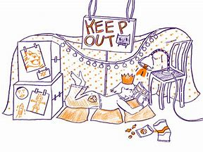 | Races – hopping, skipping, crawling  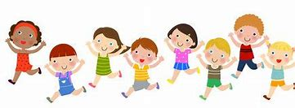 | Share a story from a book or imagination  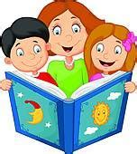
A Treasure Hunt – You pick the treasure   | Create a masterpiece – pens, paint or using objects  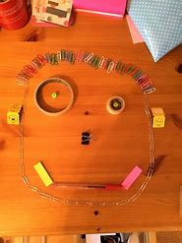 | Create a song or piece of music, make your own instruments  



