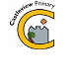
Castleview Primary School
School Closure Work – Primary 2
Updated Tasks Week Beginning – 23/03/20

Updated Core Learning – During school closure periods when possible teachers will post a weekly updated version of this document on the school website. They will change the three boxes below. Tasks may relate to the resource pack sent home or a website.

Please access our school Twitter account here to look out for home school ideas:
https://twitter.com/Castleview_PS?ref_src=twsrc%5Egoogle%7Ctwcamp%5Eserp%7Ctwgr%5Eauthor

P2A can follow Miss White here: https://twitter.com/MissWhiteCV
P2B can follow Miss Hood here: https://twitter.com/MissHoodCV

We look forward to hearing from you soon

Literacy | Numeracy | Health and Wellbeing
1.Pick a sound from your work pack (e.g. a letter sound from a-z OR a digraph such as ‘oy’). Write down 4 words which contain this sound in your jotter and draw a picture to match each one.  2. Find and practise your sounds and actions here: https://www.youtube.com/watch?v=U2HYM9VXz9k&t=508s  3. Choose a book either from home, your work pack or Bug Club and see if you can find words containing the sound you practised.  4. Choose some common words from the list in your pack. Read them and then try to write them in a sentence.  5. Here’s a little game to practise your spelling: https://www.ictgames.com/mobilePage/viking/index.html | 1. Complete 2 pages of the Maths book in your work pack.  2. Complete our Number of the day questions in your jotter.  3. Practise saying your number bonds to 10 and get an adult to test you. Here is a game to help: http://www.ictgames.com/saveTheWhale/  4. Complete your Sumdog challenge for this week.  5. If you have a grid of maths questions in your pack, do at least 3 boxes every day with an adult’s help. | 1. Watch this story https://www.youtube.com/watch?v=vZjsLK5vwNU  Adults ask your child  - -What made Gerald sad?  - -How did Gerald get over his fears?  - -What would you do if you had to dance in front of an audience?  Then, draw a poster in your jotter of all the things you are good at. Label all your pictures.  2. For physical exercise, please check out The Body Coach’s YouTube channel:  https://www.youtube.com/user/thebodycoach1  and/or  Create a GoNoodle account here https://app.gonoodle.com/ , it has lots of free movement videos.

Ongoing Core Learning

Literacy | Numeracy | Health and Wellbeing
- Book Bug  - Learning Fry’s words  - Story Writing  - Read anything and everything! | - Sum Dog  - Learning Number Facts  - Measure and compare  - Using the clock | - Dancing  - Fitness Activity  - Chat to real person not a screen  - Yoga
Ongoing Activities

Make a den – tents, pillows, blankets  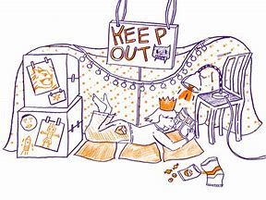 | Races – hopping, skipping, crawling  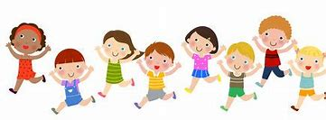 | Share a story from a book or imagination  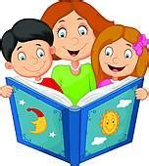
A Treasure Hunt – You pick the treasure  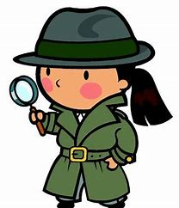 | Create a masterpiece – pens, paint or using objects  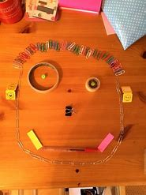 | Create a song or piece of music, make your own instruments  



