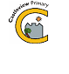
Castleview Primary School
School Closure Work – Primary 1
Updated Tasks Week Beginning – 30.03.20

Updated Core Learning – During school closure periods when possible teachers will post a weekly updated version of this document on the school website. They will change the three boxes below. Tasks may relate to the resource pack sent home or a website.
Literacy | Numeracy | Other Learning
1)Can you write the sounds b and d getting them the right way round each time. The Jolly Phonics songs can help  https://www.youtube.com/watch?v=1Qpn2839Kro  2)Can you write words with the letters b and d in them or can you get someone to read you the sentence ‘The big red dog is in bed’ and you write it.  3) Login to Book Bug. Read a book and complete the tasks by clicking on all the bugs throughout the books so we can see you have completed the books. (Please contact Miss Chavasse or Miss Carter via twitter for log in details). | 1)Login to Sumdog and complete your group’s Sumdog challenge (This week is focusing on pattern, addition and subtraction within 5).  2) Can you use subtraction in everyday life.  3)We are learning about Patterns.  -What patterns can you see around the house?  -If someone starts a simple colour or shape pattern can you complete it?  -Have a go at: https://www.topmarks.co.uk/ordering-and-sequencing/shape-patterns | 1) Can you count to 10 in Spanish? Sing along with https://www.youtube.com/watch?v=8ydJr1Is8xI  2) Can you use materials from around your house to build a boat that can float- tweet us your results! Talk about what materials float and what didn’t work!  3) Draw a rainbow or sunshine picture, put it up in your window for people on their walks to see and don’t forget to tweet us a photo of it!  - Tweet the teachers  @MissChavasseCV  @misscartercv  @MrWilsonCV

Ongoing Core Learning

Literacy | Numeracy | Health and Wellbeing
- Book Bug  - Learning Fry’s words  - Story Writing  - Read anything and everything! | - Sum Dog  - Learning Number Facts  - Measure and compare  - Use the clock to tell time | - Dancing  - Fitness Activity/walk  - Chat to real person not a screen  - Yoga
Ongoing Activities

Make a den – tents, pillows, blankets  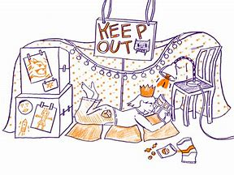 | Races – hopping, skipping, crawling  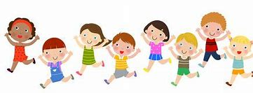 | Share a story from a book or imagination  
A Treasure Hunt – You pick the treasure   | Create a masterpiece – pens, paint or using objects  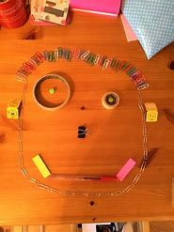 | Create a song or piece of music, make your own instruments  



