Letter Sounds
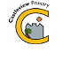

There are 42 main sounds of English. To learn to read and write we need to know the sounds and blend them together to make words or pull them apart to sound a word out to read. Hear all the letter sounds here.
https://www.jollylearning.co.uk/resource-bank/learn-the-letter-sounds/

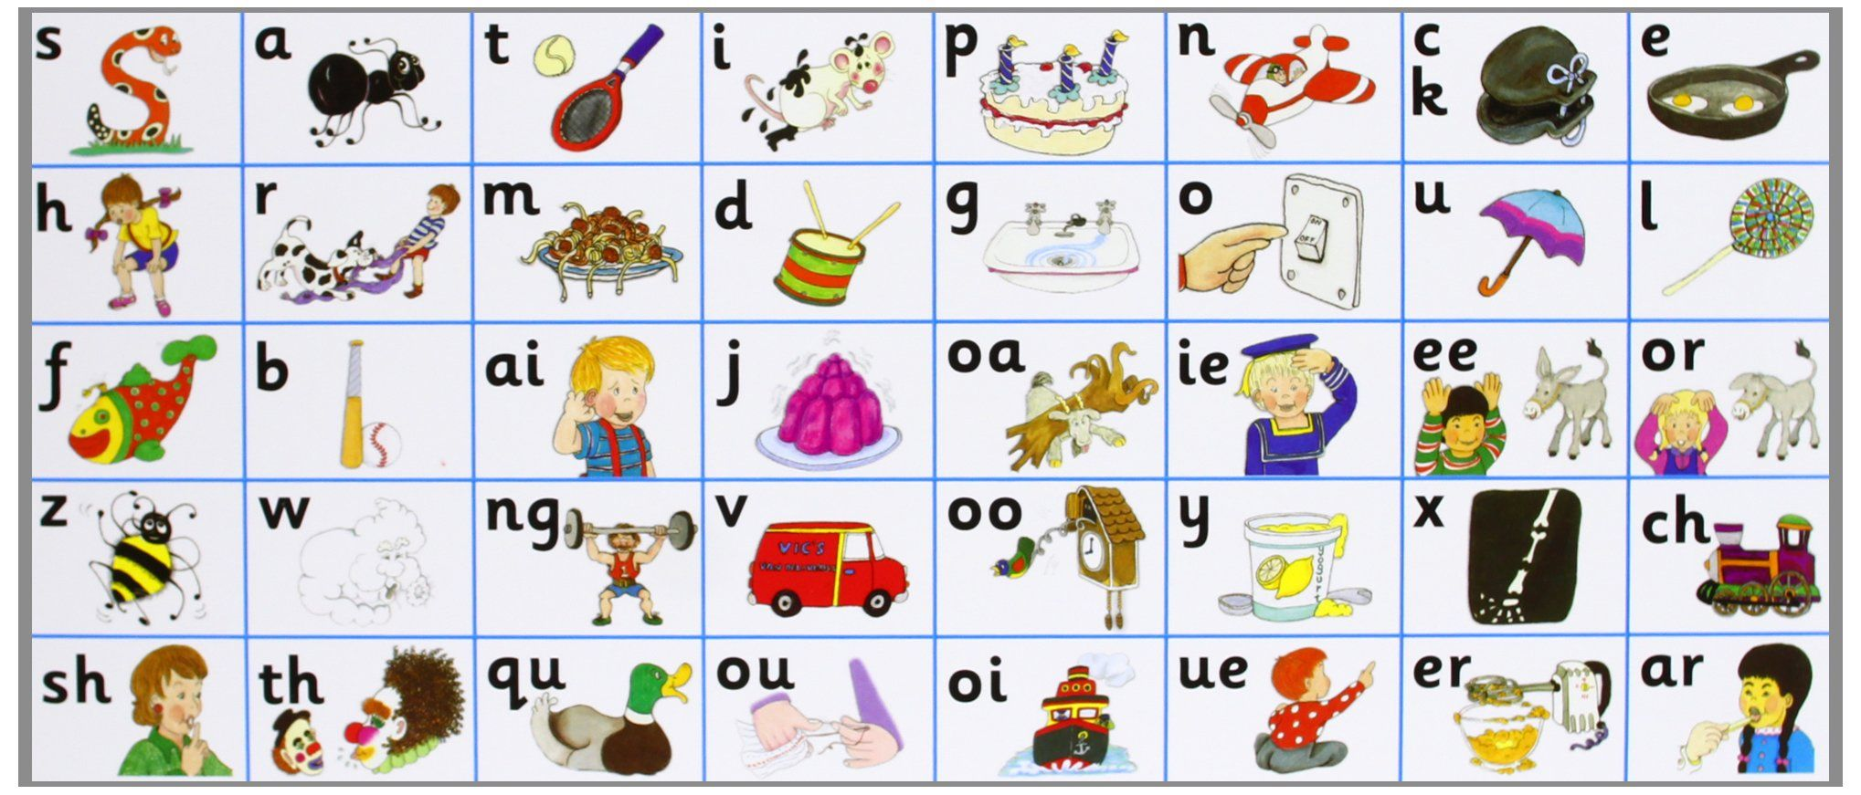

Here are some fun ways to learn my sounds at home:
Learn your sounds Bingo!  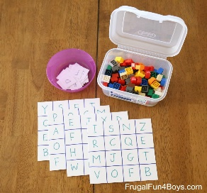 | What begins with?  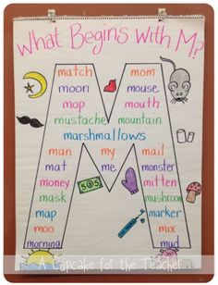 | Sound splat!  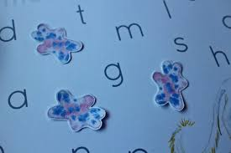 | Treasure hunting at home!  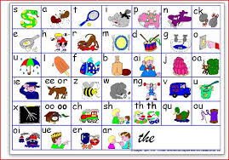
All you need is some paper, pens or anything that can make a mark on your bingo paper. Use the Jolly Phonics sounds above to help. | Choose a sound from the above and see if you can think of or write down any words beginning with that sound. | Write out your sound letters, cut them out and lay them out. When someone says the sound you have to find it and splat it with your hand! | Can you find an object in your home that begins with each of sound above?

Some links for you to access to help learn your letters and sounds.
A quick fun way to understand and learn about Jolly Phonics - https://www.youtube.com/watch?v=yVyry9jpVjI
Jolly Phonics Songs in Alphabetical Order- https://vimeo.com/106231366
Fun games to help children learn their sounds - https://www.starfall.com/h/ltr-classic/?mg=m
Letter formation practise with this fun interactive game - http://www.ictgames.com/mobilePage/skyWriter/index.html

