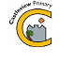
Castleview Primary School
School Closure Work – Mrs Martin – Physical Education
Updated Tasks Week Beginning – Monday 23rd March 2020

Some pupils are lucky to be taught by Mrs Martin for Health and Wellbeing – PE.
During school closure periods when possible Mrs Martin will post a weekly updated version of this document on the school website.
Physical Education / Physical Activity

Warm up with some What’s your name? exercises.
Spell out your full name and complete the activity listed for each letter.
For more of a challenge add your middle name and do each activity twice.
For variety use a favourite character’s name or another family member’s name.
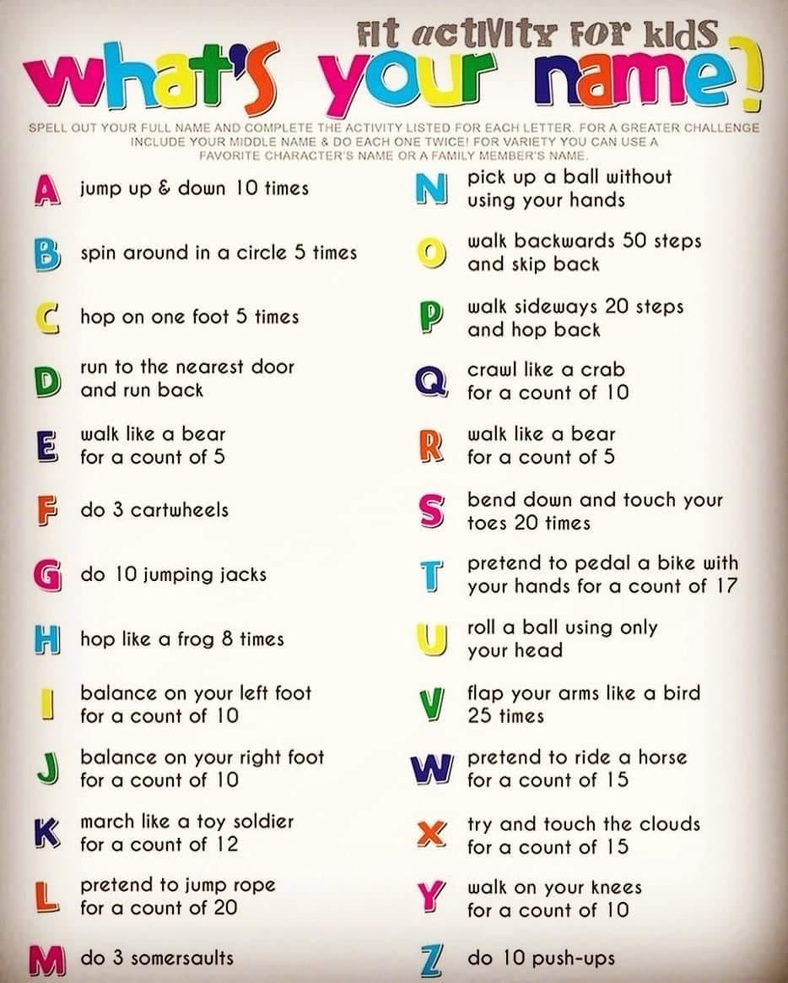

Joe Wicks is posting a new work out each day – You might want to give it a try, some of the moves are quite tricky but focus on having a go. If these are too tricky stick to the ideas above.
https://www.youtube.com/watch?v=Rz0go1pTda8

Object control - Throwing and catching
(If you don’t have a ball handy, get a piece of scrap paper and scrunch it up into a ball – that’s what I’ve done! Otherwise a spare balloon is good for indoors.)
Can you move the ball around different parts of your body?
How many times can you throw and catch the ball?
Can you balance the ball on different parts of your body?
Can you throw and catch it under different parts of your body?

Balances
Can you keep your body as still as possible, holding each balance for 3 Mississippis? Remember never balance on just your head – HANDS ALWAYS SUPPORT YOUR HEAD!
Can you balance on 1 body part, how many different ones can you think of?
Can you balance on 2 different body parts? How many different ways?
Can you balance on 3 different body parts? How many different combinations?
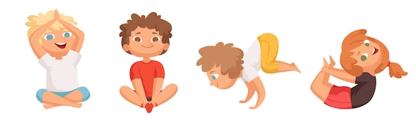

Cosmic Yoga
This is very popular at Castleview, lots of great stories to stretch and balance.
https://www.youtube.com/user/CosmicKidsYoga
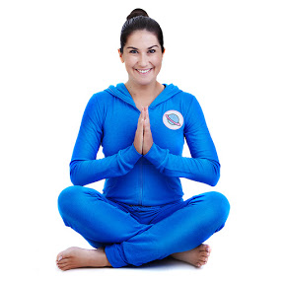

Walking
Get outdoors if you can or try a Happy Mile walk, Mrs Martin loves these to keep her body moving when she can’t get outdoors. Leslie is a lovely American lady committed to getting everyone moving.
https://www.youtube.com/watch?v=tW9IY48x1bc

You can find a whole host of other activities to do if you check out this post on my Twitter page:
https://twitter.com/MrsMartinPECV/status/1242018175891304449
Lots of great ideas but maybe just choose one or two of these to do a day! I’m going to start with the Happy dance this morning:
https://www.youtube.com/watch?v=_swUGtEpazY&feature=youtu.be
This afternoon I am going to go for some Super hero fitness Star Wars Yoga:
https://drive.google.com/file/d/1KcRu6Ob0zfMu2717GncXdCx04nryK8cB/view



