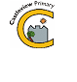
Castleview Primary School
School Closure Work – P5A
Updated Tasks Week Beginning – 23rd March

Updated Core Learning – During school closure periods when possible teachers will post a weekly updated version of this document on the school website. They will change the three boxes below. Tasks may relate to the resource pack sent home or a website.

Please share the work you do with me on twitter-@MissMcGroryCV.
I look forward to seeing your fabulous work!!
Literacy | Numeracy | Health and Wellbeing
- Up level this sentence and continue the story in any way you want – The girl walked into the rainforest and looked around.  - Fry’s Words- the 5th hundred. Study the words in List 1. Put these into interesting sentences. (Challenge- use speech marks)  - Write a newspaper article detailing the impact Covid 19 is having on schools. (Newsround will help with finding information- https://www.bbc.co.uk/newsround )  - Read the first 10 pages of ‘Terry’s Dumb Dot Story- A treehouse’. Design and descibe your own treehouse that you’d like to live in!  - Crystal Explorers game https://www.bbc.co.uk/bitesize/subjects/zv48q6f | - Practise saying and writing the 6x tables. Ask an adult to test you  - Complete three pages in your maths workbook in the pack.  - Create a timetable for your week. Include daily routines, lessons and times for play/rest.  - Create a survey- ‘your favourite food’ to complete with your family or ask friends and family online. Use tally marks to present your findings in your jotter. (Challenge- create a bar chart also)  - Problem solving- website game https://www.topmarks.co.uk/Flash.aspx?f=MagicSquares | - Walk a mile each day (inside or outside if you can!)  https://www.youtube.com/watch?v=njeZ29umqVE  - Just Dance- song/ dance of your choice. My favourite this week- https://www.youtube.com/watch?v=f3XyYOLfTU4  - Draw a picture for someone who is self-isolating to make them feel happy- post on twitter.  - WASH YOUR HANDS REGULARLY!  - PRACTISE SOCIAL DISTANCING!

Ongoing Core Learning

Literacy | Numeracy | Health and Wellbeing
- Book Bug  - Learning Fry’s words  - Story Writing  - Read anything and everything! | - Sum Dog  - Learning Number Facts  - Measure and compare  - Using the clock | - Dancing  - Fitness Activity  - Chat to real person not a screen  - Yoga
Ongoing Activities

Make a den – tents, pillows, blankets  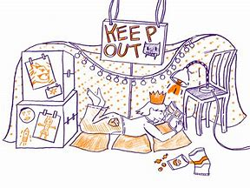 | Races – hopping, skipping, crawling  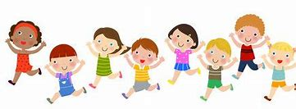 | Share a story from a book or imagination  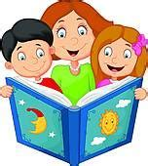
A Treasure Hunt – You pick the treasure  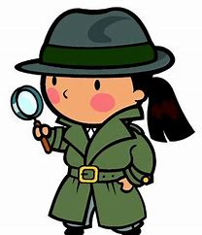 | Create a masterpiece – pens, paint or using objects  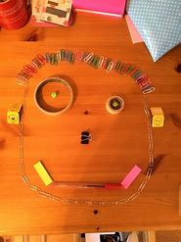 | Create a song or piece of music, make your own instruments  



