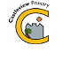
Castleview Primary School
School Closure Work – P6 – Miss Armstrong’s Literacy and Numeracy TIG Groups
Updated Tasks Week Beginning – 23rd March 2020

Updated Core Learning – During school closure periods when possible teachers will post a weekly updated version of this document on the school website. They will change the three boxes below. Tasks may relate to the resource pack sent home or a website.
Miss Chapman and Miss Armstrong have uploaded tasks for their own Literacy and Numeracy TIG Groups, please make sure you are completing the correct tasks.

Remember to post any pictures on twitter so I can see how you are all doing. Please use my twitter if you have any problems or questions too. Thinking of you all. @MsArmstrongCVP6
Literacy  Miss Armstrong’s TIG GROUP | Numeracy  Miss Armstrong’s TIG GROUP | Health and Wellbeing
- Reflect on the book you are currently reading (Matilda or The Suitcase Kid). Choose a main character and write a diary entry from the character you choose.  - Answer the following questions about the current chapter of your book that you are reading. Answer in full sentences.  - What is happening in the chapter?  - Where and when is this happening?  - How does the main character feel right now?  - Why do you think they feel this way?  - Describe what the character looks like. Use similes/alliteration.  - Focus on learning to spell the 11 words beginning with E from the list of Commonly Misspelled words (copy in your learning pack)  Use spelling strategies we use in class, then when you are confident write a Poem/ Haiku using as many of your spelling words as possible.  - Write a newspaper article detailing the impact Covid 19 is having on schools  - https://www.bbc.co.uk/bitesize/clips/zrnxvcw  Watch this clip and make notes using the 5W’s. | - Practise saying your 3 and 6 times table. Get an adult to test you  - Use the ruler in your learning packs to measure the length of 10 things in your house. Then list them from shortest to longest.  - Use your clock in your learning packs to show and write the following times:  - Half past 3  - 4:30pm  - 1 O’clock  - Quarter past 2  - 3:15pm  - Twenty past 11  - 8:40pm  - Half past 12  - 7 O’clock  - Twenty-five past 5  - In your jotter create 20 greater than/ less than/ equal to statements. For example  35 ≤ 60  3x5 = 12+3  - Website game – practice your times tables and number bonds by playing Hit the Button  https://www.topmarks.co.uk/maths-games/hit-the-button | - Take part in Joe Wicks daily gym class https://www.youtube.com/watch?v=Rz0go1pTda8  - Draw a picture for someone who is self isolating to make them feel happy and post it on twitter.  - Make a poster of our right of the month: You have the right to be kept safe and away from harm.  - Practise your Junior Tour Guide lines. Ask an adult to test you on your lines like we do in class.  - Get outside, go for a sensory walk. What can you see, hear, feel?

Ongoing Core Learning

Literacy | Numeracy | Health and Wellbeing
- Book Bug  - Learning Fry’s words  - Story Writing  - Read anything and everything! | - Sum Dog  - Learning Number Facts  - Measure and compare  - Using the clock | - Dancing  - Fitness Activity  - Chat to real person not a screen  - Yoga
Ongoing Activities

Make a den – tents, pillows, blankets  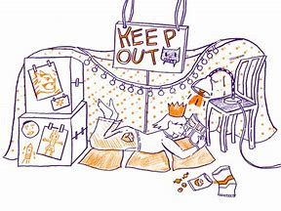 | Races – hopping, skipping, crawling  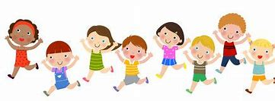 | Share a story from a book or imagination  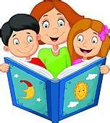
A Treasure Hunt – You pick the treasure   | Create a masterpiece – pens, paint or using objects  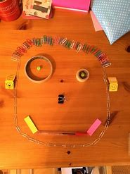 | Create a song or piece of music, make your own instruments  



