

Castleview Primary School
School Closure Work – Miss Chapman’s Literacy and Numeracy group (P6)
Updated Tasks Week Beginning – 30.3.2020

Updated Core Learning – During school closure periods when possible teachers will post a weekly updated version of this document on the school website. They will change the three boxes below. Tasks may relate to the resource pack sent home or a website.
All work should be done in the jotter that is in your home learning pack, unless otherwise stated.
Remember, your work should have a title, the date and be written using neat handwriting.
Any time you are writing, your sentences MUST have a capital letter and a full stop or other punctuation at the end ( ? !)
Parents – if you have questions please contact me via Twitter (@MissChapman_CV).
If you don’t have Twitter there is information on the school website under “NEWS’ that shows you how to access it.

Literacy | Numeracy | Health and Wellbeing
1. If you haven’t already, read the first chapter of your book and summarise it:  What happened in the chapter?  Which characters did you meet?  Where is the story set?  Is it written in 1st person or 3rd person?  Did you enjoy it and why?  2.Writing:  If you could invent a new form of transportation – one the world has never seen – what would it be?  After you have written about it, can you draw it and tweet your picture?!  3.Each day complete one of the spelling activities from the grid below for 10 words from Frys Words – the second hundred (in your packs).  You have until Friday to practise spelling your words, then your parents/carers should test you – use the back of your jotter for this.  4.Write down all the different kinds of texts you have in your home:  Recipe books?  Magazines?  Comics?  Instruction manuals?  Story books?  5.Write a diary entry about how you found the first week of home-school:  What did you like/not like?  What worked well/not well?  What was your favourite thing to do?  How have you been making sure to have fun as well?  Have you been outside each day?  How have you exercised? | 1.practise your 8 times table, get a sibling or parent to test you  2.Number of the day 80 - multiply it by 17, half it, find 25%, find 3/5, subtract 39, add 1237, write a word problem for the number  3.Website game- play ‘hit the button’ and practise your number bonds to 100  https://www.topmarks.co.uk/maths-games/hit-the-button  4. Can you find out how long it takes to get a train from:  Edinburgh to Newcastle  Edinburgh to London  Edinburgh to Glasgow Queen Street  Edinburgh to Manchester  Edinburgh to Aberdeen  5. If a train is travelling at 50 kilometres an hour, how many kilometres would it travel in:  2 hours  3 and a half hours  5 hours  7 and a half hours  Can you write down the sum you needed to get the answer in your jotter?  Which operation did you need to use?  + - x ÷ | 1.Get your daily PE lesson on YouTube, with Joe Wicks, The Body Coach. 30 minutes of PE for kids. Available live at 9am every day (don’t worry if you miss the start, you can catch it throughout the day). Just log on to YouTube.com and search for “PE with Joe the body coach”.  Web address:  https://www.youtube.com/watch?v=d3LPrhI0v-w&list=PLyCLoPd4VxBvPHOpzoEk5onAEbq40g2-k  2.Help cook a meal with your family  don’t forget to TWEET pictures to our class Twitter page!  3.Do a daily walk or run: can you check how many steps you have taken on your fitbit, phone or just old-fashioned counting!  4.Keep washing your hands for 20 seconds (the happy birthday song) and practise social distancing when you’re outside  5. practise your numbers in Spanish using our song  https://www.youtube.com/watch?v=2EuOFLYkt5Y
Ongoing Core Learning

Literacy | Numeracy | Health and Wellbeing
- Bug Club  - Learning Fry’s words  - Story Writing  - Read anything and everything! | - Sum Dog  - Learning Number Facts  - Measure and compare  - Using the clock | - Dancing  - Fitness Activity  - Chat to real person not a screen  - Yoga
Ongoing Activities

Make a den – tents, pillows, blankets  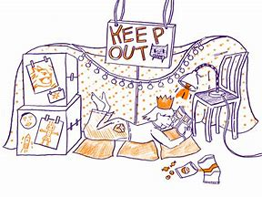 | Races – hopping, skipping, crawling   | Share a story from a book or imagination  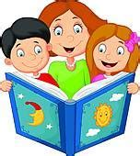
A Treasure Hunt – You pick the treasure  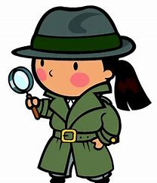 | Create a masterpiece – pens, paint or using objects  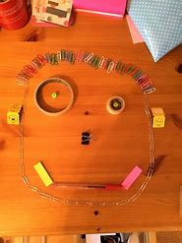 | Create a song or piece of music, make your own instruments  
Words within words  Make a list of smaller words within each word  the re | Sentence Smart  Write a sentence for each of your spelling words. | Double Up  Write each word with your right hand then with your left hand. | Back to front  Write each of your words forwards and then backwords  Cat - tac | Hangman  Ask someone to play hangman with each of your spelling words
Rap rules  Write a rap using as many of your spelling words as possible | Sort them out  Put your words in alphabetical order, shortest to longest or reverse alphabetical order | Spelling search  Find as many of your wards in magazines, or newspapers and cut and glue them into your jotter. | Cartoon connection  Create a cartoon strip using as many of your words as you can. | Word search  Create a word search for a partner with your words hidden in there
Bubble words  Write your words in colourful bubble writing | Dot spelling  Write each word using dots | Rhyming rules  Write as many words as you can that rhyme with your spelling words | Wacky words  Write your words in different directions, sizes and colours, filling up the whole jotter page! | Rainbow writing  Write each letter of the word using a different coloured pen/pencil.  sound
Silly sentence  Write a silly sentence using as many of your words as you can | Code breaker  Write a code using numbers and then write your words in code  A B C D E F G H I  1 2 3 4 5 6 7 8 9  BAD= 214 | Letter lingo  Write a letter to someone using as many of your words as you can | Story time  Write a story using as many of your words as you can. | Spelling pyramids  Write each word in a pyramid adding one letter at a time  T  Th  Tha  that

